



Project Name: Doctor Appointment PG-DAC March-2023

Documentation On

**“Doctor Appointment”**

PG-DAC MARCH 2023

Submitted By :

**Group No: 5**

|  |  |  |
| --- | --- | --- |
| * **Suraj Narayan Giram** | **PRN No.** | **230343120028** |
| * **Sourabh Namdeo** | **PRN No.** | **230343120090** |
| * **Jagruti Shivaji Patil** | **PRN No.** | **230343120033** |
| * **Chetana Sanjay Patil** | **PRN No.** | **230343120054** |

**Table of Contents**

1. Introduction 4
   1. Document Purpose **4**
   2. Project Background **4**
   3. Aim & Objectives **4**
2. Business Requirements Overview 5
3. Functional Requirements 5
   1. Patient Module **5**
   2. Doctor Module **5**
   3. Admin Module **6**
4. Non-Functional Requirement 6
5. Use Case Diagram 7
   1. Admin **7**
   2. Doctor **8**
   3. Patient **9**
6. Snapshots 13
7. Conclusion 22

List of Figures

Use Case Diagrams 7

Fig 1 Admin ...............................................................................................................................

Fig 2 Doctor ..............................................................................................................................

Fig 3 Patient ...............................................................................................................................

# Introduction:

## Document Purpose:

This document communicates the business requirements and scope for developing Online appointment booking. The scope of this document is to define the functional and non-functional requirements, business rules and other constraints requirements.

## Project Background:

In today’s fast-paced world, managing doctor appointments efficiently is crucial to ensure quality healthcare services and a better patient experience. A doctor appointment application aims to bridge the gap between patients and healthcare providers, making it convenient for patients to book appointments with doctors of their choice and helping doctors streamline their scheduling process. This application will be a user-friendly, secure, and reliable platform, accessible through web and mobile devices, providing a seamless experience for both patients and healthcare professionals. Traditional methods of scheduling doctor appointments often involve phone calls, long waiting times, and potential errors in booking. These outdated processes can lead to patient dissatisfaction, missed appointments, and inefficiencies in a medical facility workflow. To address these challenges and improve healthcare accessibility, a modern doctor appointment application is needed.

## Aim & Objectives:

Improve Patient Experience: Enhance the convenience and ease of scheduling appointments for patients. Increase Healthcare Provider Efficiency: Streamline the appointment management process for doctors. Expand Healthcare Access: Provide a platform for patients to discover and connect with a wide range of healthcare providers. Promote Patient Feedback: Encourage patients to provide feedback, leading to improved services.

# Business Requirements Overview:

* Doctor appointment application is the public web application.
* Doctor appointment application will be opened to the global, but in the phase 1, the main target is limited to a specific doctors/hospitals and city.
* There are mainly two types of users. One is the Patient and other is Doctor.
* Patients can search for the doctors available on the basis of their specialization (orthopedic, cardiologist, etc).
* Patients can search for the doctors available and even the information about the doctor.
* This system provides the functions which connect the patient and the doctor efficiently.
* This system could be maintained by Administrator.

# Functional Requirements Overview:

Doctor Appointment application consists of three modules described as below.

1. Patient Module
2. Doctor Module
3. Admin Module
   1. Patient Module
      * Patient can register and create his own account.
      * This system provides the function which allows patient to search the doctor.
      * She/He is able to browse through all existing doctor profiles based on specialization criteria.
      * The Patient could find what are appointment fees, details of all doctors and can access the contact details of doctor and finally patient can book an appointment with doctor.
   2. Doctor Module
      * Doctor can register and create his own account.
      * This system provides the function which allows doctor to upload his profile details.
      * Doctor can add his availability (time slot) details.
      * Doctor can view scheduled appointments.
   3. Admin Module
      * This system should provide all function to admin how to handle the System.
      * Admin can modify user data.
      * Admin can manage appointments (cancel/confirm).

# Non-functional Requirements

* The web application should use professional design, look and feel and color scheme.
* Users will have no limitations for accessing the application through Internet. The portal being an internet application, it is difficult specify exact number of visitor or users. Hence, we will target the system to support between 5 and 8 thousands of users on launch of phase 1.

for in



* Being a public web application, the application must follow general usability guidelines menus, navigation, colors, links and other actions provided on the screens.
* The system should be designed in such a manner that user will be able to complete tasks minimum number of steps.
* The application's user interface shall be intuitive, user-friendly, and responsive.

.

# Use-Case Diagram

## Admin:

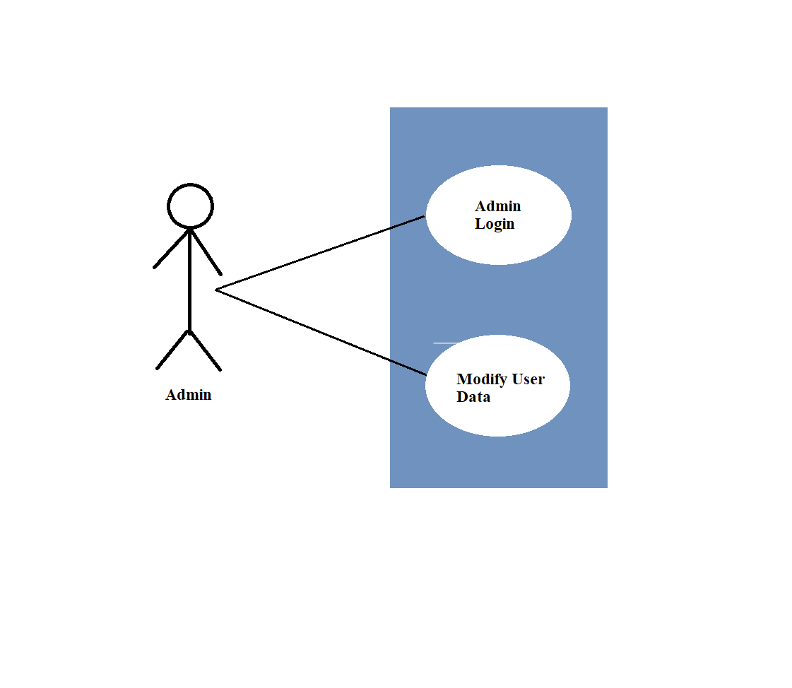

Fig. Use-Case Diagram for Admin

## Doctor :

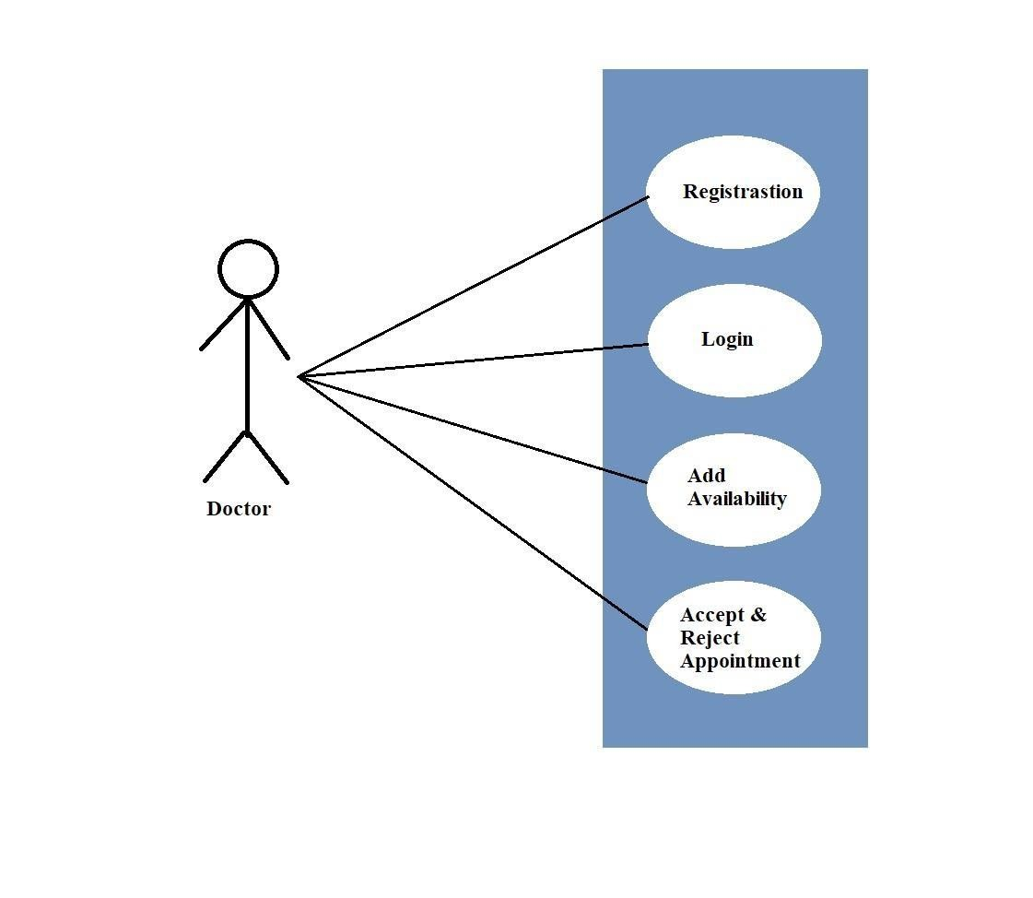

Fig. Use-Case Diagram for Doctor

* 1. **Patient :**

Fig. Use-Case Diagram for Patient.

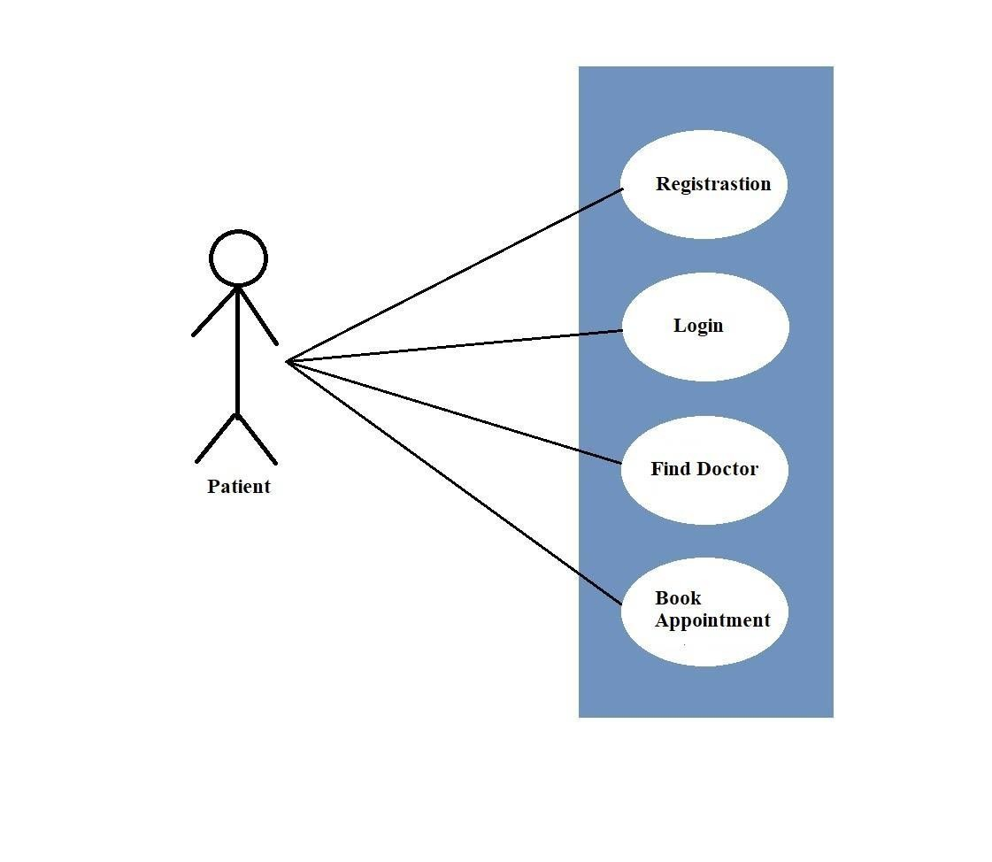

# Snapshots:

**This section will have snapshots of all the front end pages you are displaying in your project.**

# Home Page:

This page contains following controls

* + - Home



•

•

•

Login

Doctor Registration Patient Registration

**8.2 Login Page**

Following snapshot shows the Login page for Doctor Appointment Application.

* 1. **Doctor Registration Page**
     + User will get registered as Doctor.

**8.5.1 Doctor Home Page**

**8.4.1 Doctor Add Availability Page**

**8.4.3 Appointment List**

**8.5 Patient Registration Page**

**8.5.1 Patient Home Page**

* + 1. **Doctor Category Choose**
    2. **Slot Booking page**

1. **CONCLUSION AND FUTURE SCOPE**

Our System provides a very user-friendly platform where Patient can easily search for the Doctor which available for appointment slot also Doctor will be able to upload slot timing which are available.

the future of doctor appointment applications involves leveraging technology, data, and innovative solutions to provide more accessible, efficient, and personalized healthcare services to a broader population.

